**COMP 246 Object Oriented Software Engineering Project Assignment – Please refer to Mohamed Khan, course lead, for any edits to the document**

**Part B ( 14 Marks)**

Part A of Term Project – the Software Requirements (SRS), that you have just completed was necessary for the next two software design assignments Parts B & C to be completed. Parts B & C will constitute the software design/architecture document (SDD) – the critical outcome of the course.

**Bridge Diagram ( Pressman Text Chapter 8) shows the overview of Problem Statement &Analysis followed by Design : a roadmap**

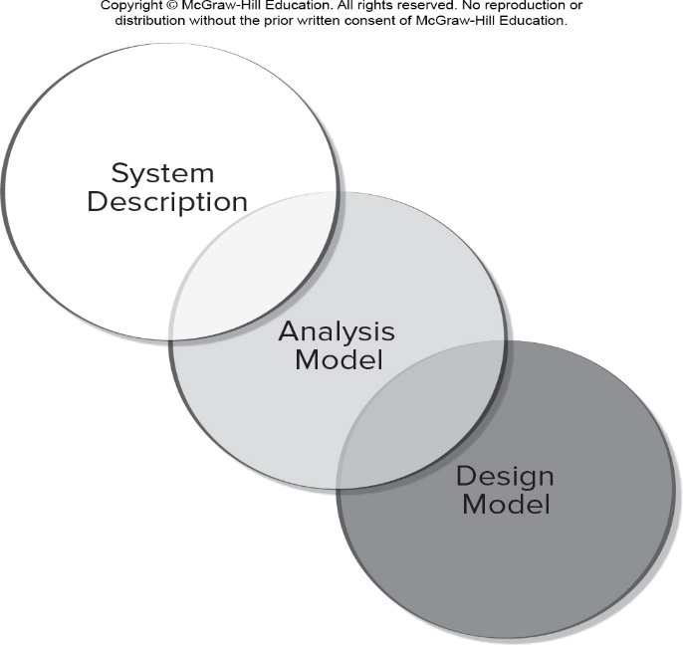

|  |
| --- |
| **Due Date for Part B** -- Week 9 ( See Assessment folder) |

|  |  |  |
| --- | --- | --- |
| Section 1: Requirements Edits to Part A |  |  |
| 1.1 Perform corrections and edits to the Part A SRS document--due week 5 for professor review and feedback. | **1.0** |  |
| **Software Design Architecture – Part B** |  |  |
| Section 2: Overview Model |  |  |
| 2.1 Who are the intended users of the SDD document  2.2 Draw an Architectural Context diagram -ACD  ( HOW overview) This diagram must be derived from your Context Flow Diagram (WHAT overview) that you completed in Part A.  Show both the “What” Diagram (from Part A) & the “How” diagram from Chapter 10. | **1.0** |  |
| Section 3.0 Modularization - Develop the Design classes as per Sub-system Component |  |  |
| 3.1 Partition the analysis model ( See SRS document) into design components/subsystems.  Note: This exercise should not be difficult if in Part A you have already sub-divided your application into subsystems or Modules.  3.2 Use the CRC template given in the Case tool Visual Paradigm to plan the Responsibilities and Collaborations of each of the classes.  3.3 Draw the design classes diagram from your domain classes–follow the subsystem components and enter the methods/responsibilities from the CRC document. Ensure that all Use Cases are accounted for. Emphasize navigations arrows to illustrate the messaging pathways.  Reminder: For this exercise, To manage your time, limit to a max of 4 subsystem components. | **1.0**  **1.5**  **1.5** |  |
| Section 4.0 Framework M(odel) V(iew) C(ontroller) for either Mobile or Web Application |  |  |
| 4.1 For each Class diagram subsystem component  Draw the MVC pattern diagram to include   * UI component ( V) * Controller component ( C) * The Model or Object Entity Classes component ( M).   Note: Do this exercise for each subsystem component separately. Pay careful attention to re-usable classes.  4.2 Draw TWO full Sequence diagrams -SD ( different from the Systems Sequence Diagram -SSD in Part A) of each of TWO separate goal Use Cases. This exercise should follow the MVC pattern.  4.3 Draw TWO State Machine Diagrams to show the transition over time of each of TWO separate objects . You may use the same TWO State Machine Diagrams done in Part A assignment. | **3.5**  **1.0**  **1.0** |  |
| **Section 5 - Data Layer** |  |  |
| **5.1.** Show a database schema with attributes, data types and sizes for each of the tables – the data mapping from your Class diagrams. Your ERD of Part A will be important to guide you in PKs and FKs. | **1.5** |  |
| **5.2 Update your Technology List** | **0.5** |  |
| **Section 6 - Update the Gannt chart to include Part B tasks Sections 1-5** | **0.5** |  |
|  | **14** |  |

Use this Saving Format -- **<Name of Course>-<Name of Project>-< Assignment Part - XXX>**

e.g **COMP 246—XYZ --Part B – Software Design Document**

The names of the Group Members must appear on the document cover page.

Note : Package Part A & Part B

**Part C will be uploaded in the next week or two.**